Flamenco Workshops
at the Joy of Motion Dance Center
Maestro Antonio Santaella
Technique: Choreography (Tarantos):
Level: All levels (Beginning I and above) Level: Int/Adv (Beg II are encouraged to attend)
Friday, April 7, 6:30 - 7:30 pm Friday, April 7, 7:30 - 9:00 pm
Saturday, April 8, 3:00 - 4:00 pm Saturday, April 8, 1:30 - 3:00 pm
Sunday, April 9, 4:30 - 5:30 pm Sunday, April 9, 3:00 - 4:30 pm
Friday, April 14, 6:30 - 7:30 pm Friday, April 14, 7:30 - 9:00 pm
Saturday, April 15, 3:00 - 4:00 pm Saturday, April 15, 1:30 - 3:00 pm

$35 each/ $30 in advance/ $150 for all 5 $45 each/ $40 in advance/ $200 for all 5
All 10 workshops $325

All workshops held at the Joy of Motion Dance Center Bethesda location, 7315 Wisconsin Ave., Ste. 180E, Bethesda, MD 20814
Register online at www.joyofmotion.org (Spring workshops) or call (301)986-0016

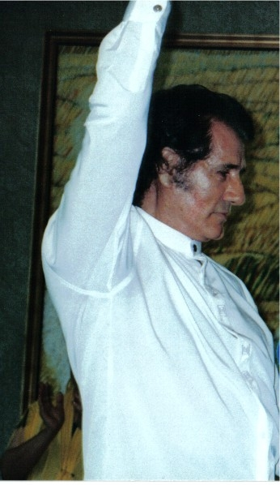
Antonio Santaella is a native of Valderrubio, a small town in Granada. He started learning flamenco as a child from the gypsies of Sacromonte de Granada, focusing in particular on their style and arms. Critics have described Santaella's footwork as "exceptional," and his dancing as one with "an intensity, virtuosity and sound effect in a way I have never seen." Noted flamenco figures such as Omayra Amaya started their flamenco careers with Santaella.

As a young man, he trained intensively with Rayito and Antonio Marin. Early in his career, he performed with numerous dance companies in Spain, particularly in Jerez, including El Principe Gitano and the companies of Pepe Moto, Roberto Iglesias and Rafael Aguilar. It was during his three years with Rafael Aguilar that he began to flourish as a choreographer.

Santaella first came to the United States as a dancer with the Iberian Dance Theatre de Luna Toledo with whom he toured the United States for three years. He then founded his own company with whom he performed in numerous venues in New York, including Carnegie Hall, Radio City Music Hall, the Waldorf Astoria, and Chateau de Madrid; Las Vegas; and Los Angeles, and abroad in Mexico and Paris. His performances met with great critical acclaim.

Santaella relocated to Puerto Rico. There he founded Mosaico Almudejar, a multidisciplinary artistic organization dedicated to producing theatre, music, and dance productions. Through Mosaico Almudejar, he produced "Llanto por Federico Garcia Lorca" in 1998, which manifested the writings of Lorca through flamenco music and dance; in 2001, "Julia en Flamenco...para el Mundo;" and in 2005, "Tres Genios en un Tiempo," where he brought to life the writings of poets Federico Garcia Lorca, Julia de Burgos, and Pablo Neruda. He is currently staging his next production "El Crimen Fue en Granda," which will open in October 2006.
Santaella currently teaches flamenco in Puerto Rico and is regularly invited for workshops and master classes abroad. In March 1999, he was invited to perform "El Sombrero de Tres Picos" with the Symphony Orchestra of San Antonio Texas. He has appeared television programs and films; he is frequently requested to choreograph for television and other special events. He divides his time between Puerto Rico and Spain.

